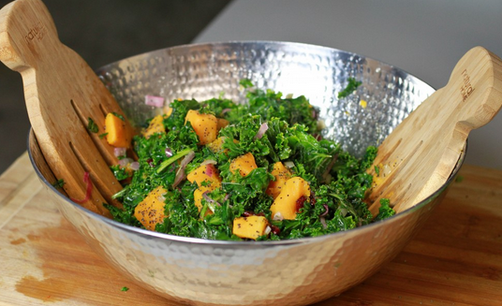
Ingredients

- Spinach 3 red onions
- Dates 2 teaspoons lime zest
- Vegetable oil Salt and pepper to taste
- ½ cup lime juice

Procedure
- Blend 4 pitted dates, 1 cup vegetable oil, lime juice and zest in a blender until smooth.
- Cut red onions
- Heat oil in a medium saucepan and cook onions until golden brown and crisp
- Chop dates
- Combine chopped dates, spinach, onions and dressing

