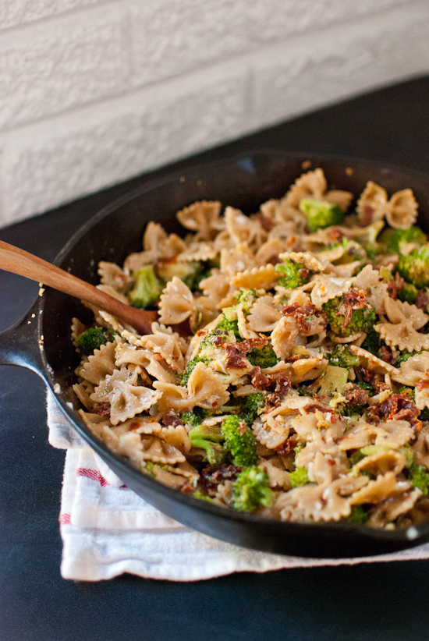
Ingredients

Total
- 5 boxes of pasta
- 4 pinches of salt
- 1 c. olive oil
- 2 onions
- ½ lb. parmesan cheese
- chopped garlic

Procedure

- First, bring ≈ 12 c. water to a boil
- Next, add 2 pinches of salt to prevent the pasta from sticking
- Meanwhile, dice the onions
- Chop the garlic
- Grate the cheese
- Sauté onions, garlic and olive oil on low heart making sure not to burn garlic.
- Add in the tomato sauce and cook fro another 4 minutes
- Once the water is boiling, add 2 boxes of pasta and cook until soft
- WITH ADULT SUPERVISION drain pasta and return to pot
- Complete pasta steps once again
- Combine everything

