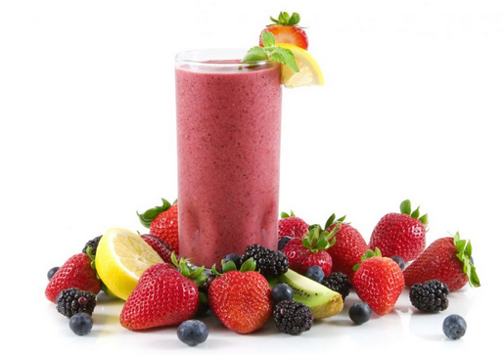
Ingredients

- 20 lemons – juiced and zested
- Water and sugar to taste
- 15 ripe kiwis – peeled and diced
- 1 quart of sorbet

Procedure

- Add lemon juice and zest to a blender with water and sugar to taste.
- Blend until a sour lemonade-like mixture is formed.
- Add kiwi and blend until smooth.
- Serve immediately and top with 1 tsp. sorbet.

