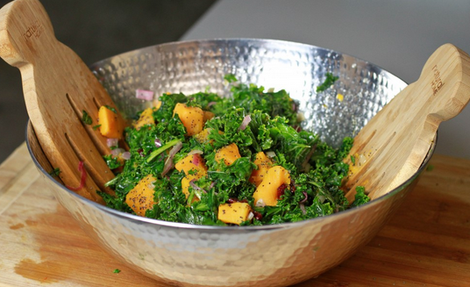
Ingredients

- 2 lbs arugula
- 2 lbs baby spinach 8 teaspoons honey
- 30 clementines 8 teaspoons Dijon mustard
- 2 cup shelled sunflower seeds Juice of 4 limes
- 1 ½ cup olive oil Salt and Pepper
- ½ cup rice wine vinegar

Procedure
- Wash and dry the spinach and arugula. Place in large bowl.
- Peel and section the clementines and add to the bowl.
- Place the sunflower seeds in a dry pan nonstick pan over medium heat for 1-2 minutes until golden brown. Be sure to keep a close watch on them so they do not burn.
- In a separate bowl, whisk the vinegar (sour), honey (sweet), mustard (spicy) and lime juice (sour/sweet) together and slowly add in the oil.
- Smash salt and pepper and season dressing to taste. Adjust ingredients until the dressing is well balanced.
- Toss the salad with the dressing, adding little bits at a time. Try not to break up the clementine segments.

