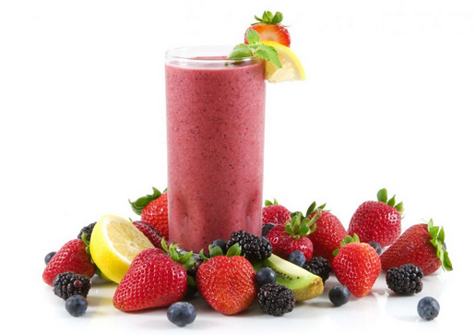
Ingredients

- 2 watermelons – seeded and cut up
- 10 oranges – juiced
- water
- some type of frozen fruit (or ice)

Procedure

- Blend watermelon, orange juice, and water.
- Taste (a very, very small portion – with a tasting spoon) to ensure quality.
- To assemble, spoon frozen fruit into a cup, and top with chilled watermelon juice mixture.

