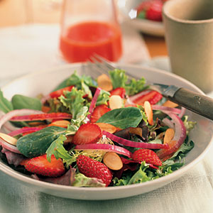
Ingredients

- 10 cups of watermelon
- 15 tablespoons of honey
- 10 tablespoons of wine vinegar
- 2.5 Tablespoons of salt
- 50 cups of salad greens
- 5 cups of chopped onions(thinly)
- 15.5 cups of strawberries
- Pepper to taste

Procedure
- Dice watermelon, slice strawberries and chop onions
- Combine watermelon, honey, wine vinegar, vegetable oil, and salt into blender
- Blend until smooth
- Move to serving area

