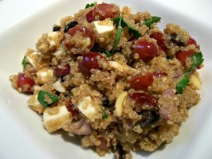
Ingredients

- 28 C cooked Quinoa
- 14 C grapes
- 12 celery stalks
- 4 Tablespoons of orange zest
- 8 tablespoons fresh squeezed orange juice
- 8 tablespoons olive oil
- 4 tablespoons honey
- Salt and pepper to taste

Procedure
- Cook the quinoa
- Cut grapes in half, and cut celery
- In a small bowl combine orange zest, orange juice, honey, vinegar, oil, and salt and pepper
- Mix everything together

