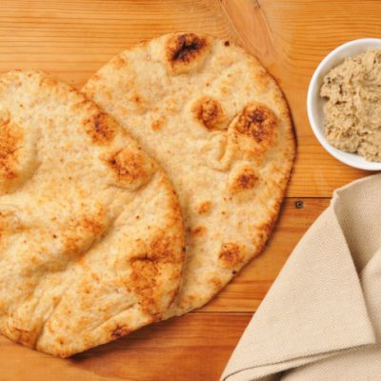
Ingredients

- 15 cups of flour
- 15 tablespoons of olive oil
- 7 teaspoons of fast active yeast
- 5 cups of water
- 4 teaspoons of salt

Procedure
- In a large bowl combine yeast, salt, and flour
- Make a space in the center of the bowl and add water and oil
- Stir slowly
- Knead dough for 4 to 5 minutes
- Split equally into small balls and let sit for 5 minutes
- Heat dry skillet on medium to high heat
- Cook bread for 1 minute or less on both sides until golden brown
- Remove from pan and cover with towel

