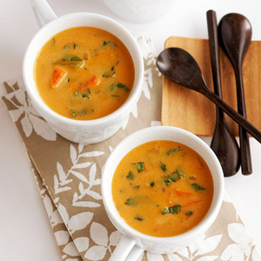
Ingredients

Total
- 8 carrots chopped
- 2 Green sweet peppers
- 3 onions
- 4 tablespoons vegetable oil
- 2 cans pumpkin
- 60 ounces coconut milk
- 60 ounces vegetable broth
- 8 tablespoons brown sugar
- 2 teaspoons ginger
- Salt and pepper to taste

Procedure

- Chop the carrots, onions and pepper
- In a large pan, cook over medium heat until tender
- In a bowl combine pumpkin, coconut milk, vegetable broth, brown sugar and spices
- Stir in the cooked vegetables
- Bring to a boil
- Reduce heat and simmer for about 10 minutes.

