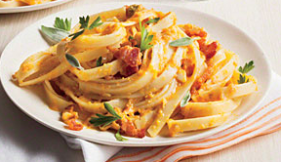
Ingredients

Total
- 6 boxes of Fettuccine
- 6 Cups Pumpkin Puree
- 1 pound parmesan cheese
- ¾ cup milk
- 1/3 cup butter
- Parsley
- Sage
- Garlic
- Salt and pepper to taste

Procedure

- First, cook the pasta according to the directions on the box. You may need to use two pots to cook all the pasta.
- WITH ADULT SUPERVISION drain the pasta
- Meanwhile, finely chop the garlic, sage and
- Heat up a pan over medium heat
- Add the pumpkin puree, parmesan cheese, garlic sage and salt and pepper
- Add pasta and milk and butter and mix to coat the pasta
- Cook for 2 minutes or until thoroughly hot
- Sprinkle with sage and parsley

