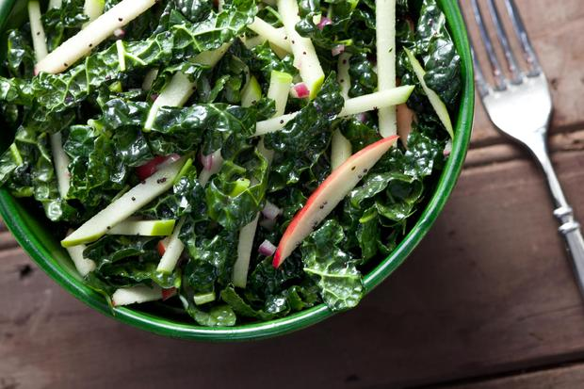
Ingredients
- Kale
- 12 apples
- 9 tablespoons cider vinegar
- 6 tablespoons honey
- 6 tablespoons Dijon mustard
- 9 tablespoons vegetable oil
- 3/4 teaspoon salt
- 1 cup oil
- pepper to taste

Procedure

- Wash and dry the kale
- De-stem the kale
- Cut kale into strips
- Cut apples into thin strips
- Mix the Kale and apples together
- In a separate bowl, combine the vinegar, honey, mustard, and salt. Slowly mix in the oil.
- Mix the salad and dressing together and toss until well combined.

