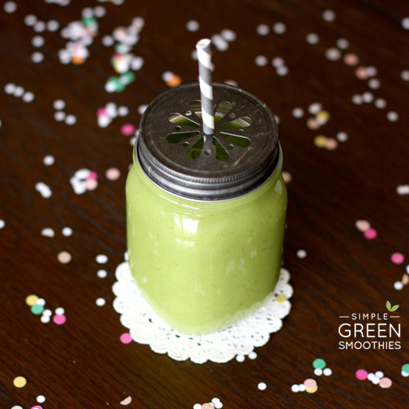
Ingredients

- 12 cups of frozen spinach
- 12 cups of water
- 6 cups of pineapple
- 12 bananas
- 12 cups of mango

Per Blender:
- 2 cups of frozen spinach
- 2 cups of water
- 1 cup of pineapple
- 1 cup of mango
- 2 bananas

Procedure

- Add 2 cups spinach to blender
- Add 2 cups of water
- Blend until smooth
- Add 1 cup of pineapple
- Add 1 cup of mango
- Add 2 bananas
- Blend until smooth

