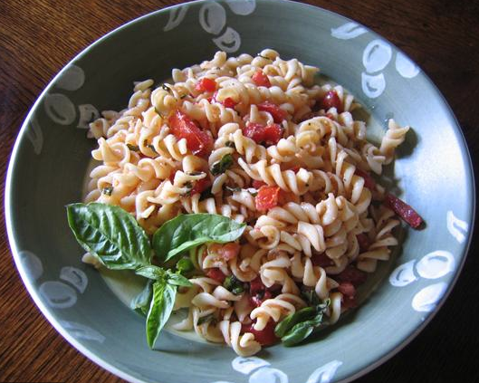
Ingredients

- 1 box of pasta
- 2 red bell peppers
- 1/3 c. cilantro
- 1 jalepeno pepper
- 1 can small white beans
- 4 cloves of garlic
- 1 tsp. salt
- 2 yellow onions
- 1 bag frozen corn
- ½ c. of olive oil
- 2 celery stalks
- (Salt & pepper to taste)

Procedure

- First, bring water (6 c. per box) to a boil.
- Add pasta (with a pinch of salt) and cook for 12 minutes, or until pasta is desired consistency.
- Drain pasta and allow it to cool.
- Meanwhile, put a large pot on a medium heat burner. Coat with olive oil.
- Dice onions and add to the pot. Cook for 5 minutes, until soft
- Chop celery, garlic and jalapeno, and add to the pot. Cook together for 10 minutes.
- Dice the red bell pepper. Drain and rinse the white beans. Thaw the corn. Add these 3 ingredients to the pot, cook for another 5 minutes.
- Chop cilantro.
- In a large metal bowl, mix cooked pasta, vegetables, and chopped cilantro. Stir until combined.

