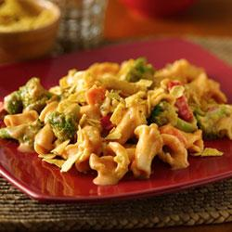
Ingredients

Total
- 6 boxes of rotini pasta
- 4 pinches of salt
- 1 c. olive oil
- 4 heads fresh broccoli florets
- 4 red peppers
- 3 squash
- 3 cans black beans
- 4 cans Old El Paso mild red enchilada sauce
- 2 1/3 c. sour cream
- 6 ¼ c. Mexican shredded cheese
- taco shells, crushed

Procedure

- First, bring ≈ 12 c. water to a boil
- Next, add 2 pinches of salt to prevent the pasta from sticking
- Meanwhile, dice the broccoli
- Cut the pepper into strips
- Cut the squash into slices
- Drain and rinse the black beans
- Once the water is boiling, add 2 boxes of pasta and cook until soft
- WITH ADULT SUPERVISION drain pasta and return to pot
- Complete pasta steps once again
- Add the vegetables to a skillet with ½ c. olive oil and both enchilada sauces
- Remove from heat and stir in sour cream, cheese, and cooked pasta immediately
- Allow to cool slightly and top with taco shells
- Separate into two serving dishes (1 for each lunch), cover, and begin cleanup

