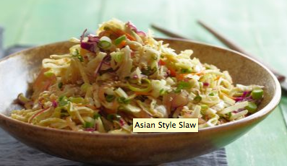
Ingredients

- Kale
- Cabbage
- Scallions
- Red onions
- ¾ Cup soy sauce
- ¾ Cup lemon juice
- ¾ cup vegetable oil
- 6 tbs vinegar
- 6 tbs brown sugar
- 6 tsp sesame oil
- 6 Tbs grated ginger

Procedure
- Wash the kale
- Grab the kale by the stem and strip off the leaves
- Cut the kale into ribbons
- Wash the cabbage and cut into ribbons
- Cut the red onions
- Cut the scallion
- Grate ginger
- Combine kale, cabbage, onions and scallions in a bowl
- Next, in a separate bowl combine the soy sauce, sesame oil, vinegar, lemon juice, oil, ginger and brown sugar.
- Pour over the vegetables and mix.
- Add salt and pepper to taste

