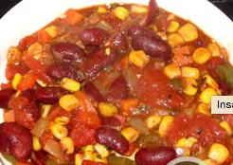
Ingredients

Total
- 8 onions, chopped
- 10-15 carrots, chopped
- 1 head garlic, minced
- 8-12 green or red peppers, chopped
- 6 ribs celery, chopped
- 6 cans chopped tomatoes (or 10-15 fresh)
- 3 cans kidney beans with liquid
- 3 chipotle chilis, in adobo sauce
- 3 tablespoons chili powder
- 3 tablespoons cumin
- 4 teaspoons dried oregano
- 2 lbs button mushrooms, chopped
- 2 bunches cilantro
- 6 limes

Procedure

- Dice up the onion, carrots, peppers, mushrooms, celery and garlic
- Heat oil in a large saucepan on medium heat and sauté the onions, carrots, and celery until soft (about 10 minutes)
- Stir in the peppers, garlic, and chili powder. Cook until soft for about 6 minutes
- Mash the cumin in the mortar and pestle and add to the vegetables.
- Stir in the mushrooms and cook for another 10 minutes
- Stir in tomatoes and beans, add the oregano, salt, and pepper and bring to a boil.
- Reduce to a simmer, season to taste, and serve with chopped parsley and limes on the side.

