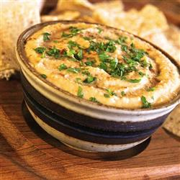
Ingredients

- 2 onions, diced
- 6 sweet potatoes, chopped in small pieces
- 2 TBS olive oil
- 3 chipotle peppers in adobo, chopped
- 6 cloves garlic, chopped
- 2 TBS cumin, ground
- 2 TBS apple cider vinegar
- 1/2 cup apple juice
- 4 cans chickpeas, rinsed
- Salt and pepper to taste
- 1 bunch parsley, leaves separated from stems
- 12 cucumbers, cut into thin rounds

Procedure

- In a non-stick skillet, toast the cumin seeds on low heat until smoky, about 1 minute. Place in mortar and pestle and grind.
- Put olive oil in a large pot on low heat and add onions, cook for 5 minutes until softened.
- Add sweet potatoes, chipotles, and chopped parsley stems and cook for 10-15 minutes, until tender. Mix frequently so the potatoes don’t burn.
- Add the garlic, ground cumin, and a little salt and pepper along with the apple cider vinegar and apple juice, cook together for 5 minutes.
- Add the rinsed chickpeas and simmer for as 5 more minutes.
- Use an immersion blender (or a regular blender) to blend everything together, leaving it as smooth or as chunky as you like.
- Serve on top of a thinly sliced cucumber with a leave of parsley.

