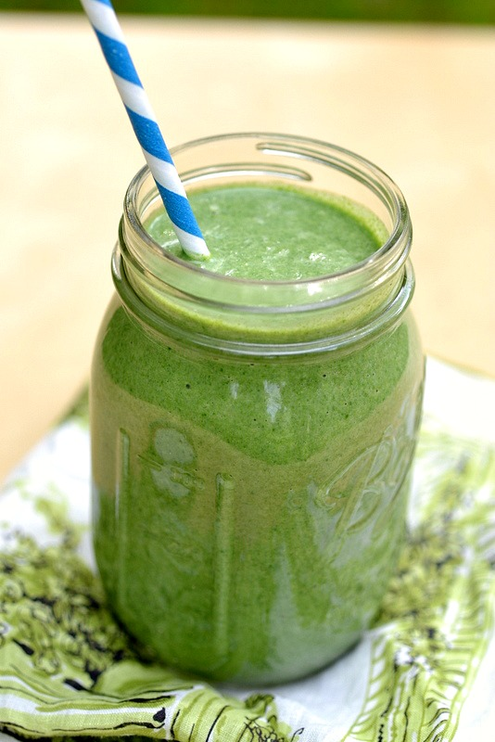
Ingredients

Total Per Blender
- Kale
- Bananas
- Apple juice
- 14 c. frozen blueberries
- 1 ½ c. kale
- 2 bananas
- ½ cup apple juice
- 2 c. frozen blueberries

Procedure

- First, wash and de-stem the kale
- Next, add the apple juice.
- Blend until smooth.
- Then, add the remaining ingredients (listed under “per blender” at the top right-hand side).
- Blend thoroughly.
- Repeat procedure until the ingredients are gone.
- Pour smoothie into cups and serve.

