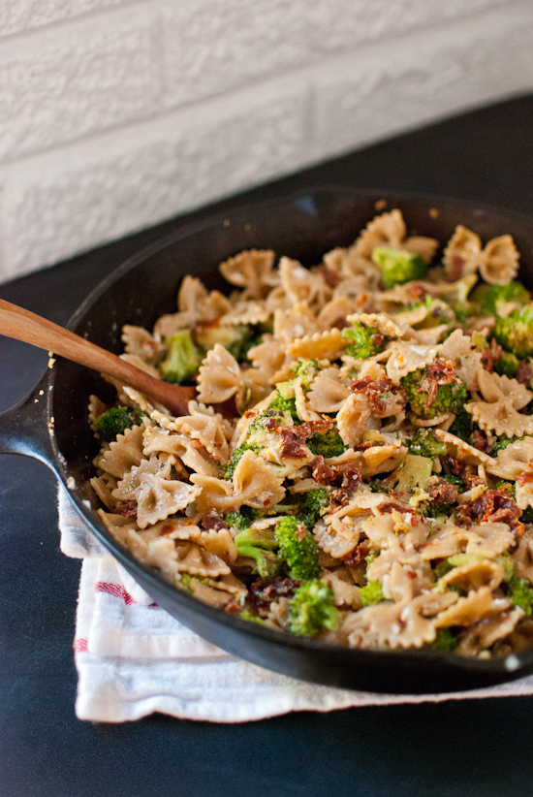
Ingredients

Total
- 5 boxes of whole wheat penne pasta
- 5 bunches Kale
- 3 TBS salt
- crushed black pepper
- 1 c. olive oil
- 4 limes
- 5 onions
- 3 bags frozen corn
- 5 jalepeno peppers
- 2 heads garlic
- 1 block parmesan

Procedure

- First, bring a big pot filled about 2/3 with water to a boil.
- Add 1 tsp of salt for every box of pasta being boiled.
- Boil the pasta (try to time it so it is ready when the sauce is)
- Put a large pot on low/medium heat and add olive oil.
- Dice the onions and add them to the pot, stirring often. Cook for 10 minutes or so.
- Smash and mince the garlic into small pieces. Add it to the pot with the onions (and kale stems) and cook for 3 minutes together, until the garlic is a bit golden.
- Wash the kale and remove the leaves from the stems. Chop the stems into very small pieces. Add to the oil at the same time as the garlic and hot peppers.
- Remove the seeds from the peppers. Mince the peppers into small pieces and add with the garlic and kale stems. WASH YOUR HANDS AFTER TOUCHING PEPPERS. DO NOT TOUCH YOUR EYES.
- Chop Kale in small pieces and add to the oil/veggie mixture. Season with a little fresh ground salt and pepper. Cook for 10-15 minutes, until the kale begins to soften.
- Once the water is boiling, add 1-2 boxes of pasta at a time (don’t overflow your pot) and cook according to instructions on the box.
- WITH ADULT SUPERVISION drain pasta and put it in a large metal bowl. Stir in a small amount of olive oil to prevent sticking.
- Thaw the corn in the bag by running it under warm water. Heat a separate dry non stick skillet over a medium flame. Add the softened corn and cook till kernels start to brown. Turn off the heat and add to the cooked pasta.
- Taste the vegetables, adjust seasoning.
- Pour the vegetables over the pasta and mix.
- Cut limes and squeeze the juice (and cheese) into the pasta as you stir.
- WITH ADULT SUPERVISION Grate the parmesan cheese (BE CAREFUL, DO NOT GRATE YOUR FINGERS)

