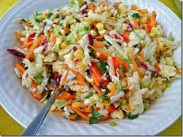
Ingredients

- 6 tbsp. olive oil
- 16 ears corn – shucked and silks removed, kernals cut off ears
- 4 bunches red Russian kale – leaves and stems shredded
- 12 sweet peppers, diced
- 1 bag of carrots – peeled and cut into fine strips (use a peeler)
- 4 red or green onions, diced
- 4 red chilies – finely chopped
- 1 bunch parsley, leaves and stems minced
- 4 tbs fresh basil leaves, minced
- ½ c. low-fat plain yogurt
- 2 tbs Dijon mustard
- 2 lemons – juiced and zested
- ½ c. white rice wine vinegar
- 3 tbs sugar
- 6 cloves garlic – minced
- Salt and pepper to taste

Procedure
- Carefully cut the corn kernels from the ears of grilled corn.
- Prepare a frying pan with 3 tbsp olive oil and add kernals of corn. Grill until slightly browned. Remove and set aside to cool.
- Combine corn kernels, kale, sweet peppers, carrots, onions, chilies, parsley, and basil.
- Separately, combine yogurt, mustard, 3 tbsp olive oil, lemon juice, white rice wine vinegar, sugar, and garlic. Salt and pepper to taste.
- Top vegetables with rice wine/yogurt mixture to taste (remember, you can add more but you cannot take out).
- When the perfect mixture is achieved, serve and top with lemon zest.

