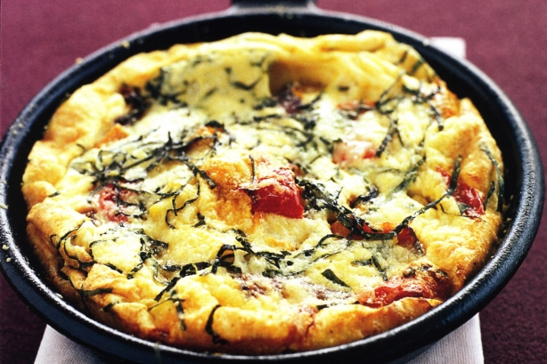

Ingredients

- 6 small onions, chopped
- 6 potatoes, chopped
- 3 broccoli heads
- 18 eggs
- 3 Cups kale, destemmed and chopped
- Feta cheese
- 9 TBS olive oil

Procedure

- Chop the onions, potatoes, broccoli and kale
- Heat 3 TBS olive oil in a pan over medium-low heat
- Saute the onions for 3-5 minutes
- Add the potatoes and cook until soft (about 10 more minutes)
- Add the broccoli and kale and cook until soft (about 5 minutes). Season with salt and pepper.
- In a separate bowl, whisk eggs and salt and pour into the skillet
- Cook on low heat until the eggs are firm (about 3 minutes), with a lid (or bowl) on top of the skillet to create some steam. BE CAREFUL--- THE BOWL WILL BE HOT!
- Garnish with feta cheese and chives

