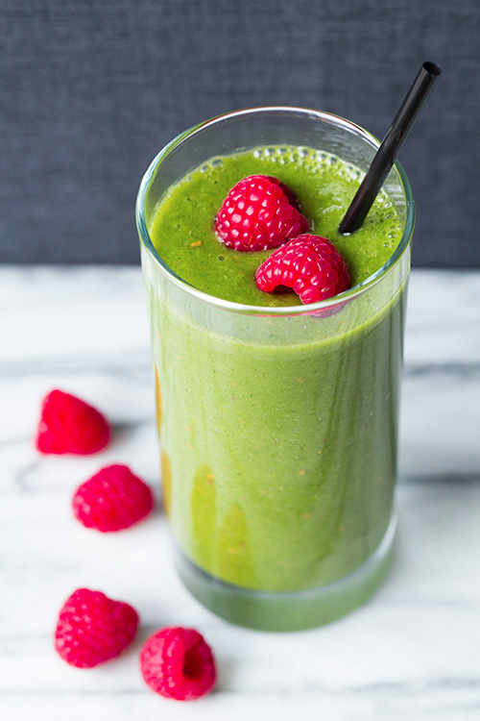
Ingredients Per Blender

- ¾ Cup Strawberries
- ¾ Cup raspberries
- ½ Cup Blueberries
- 1 banana
- 2/3 Cup almond milk
1 Cup kale, destemmed

Procedure

- Wash and destem the kale
- Blend the almond milk and kale until smooth
- Add the remaining ingredients until smooth

