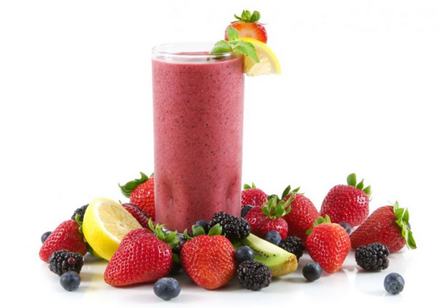
Ingredients

- 3 quarts frozen strawberries
- 1 quart frozen pineapple – cut into 1 inch cubes
- 2 cups coconut milk
- 2 cups water

Procedure

- Add strawberries, pineapple, coconut milk, and pineapple juice to blender.
- Blend until no chunks are present.
- Taste (a very, very small portion – with a tasting spoon) to ensure quality.
- Sweeten with a little bit of honey if necessary.
- Place in the fridge until ready to serve.

