Ingredients

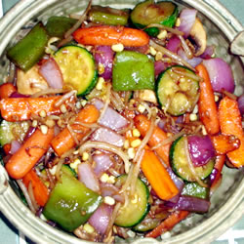
- 2.5 Cups of Soy sauce
- 2.5 Cups Vegetable Broth
- 24 Chopped Carrots
- 7 chopped peppers
- 6 sliced onions
- 6 Tablespoons of Wine Vinegar
- 6 Tablespoons of sesame oil
- 3 Tablespoons of sugar
- 9 Cups of rice

Procedure
- Wash all vegetables
- Slice carrots ,chop peppers and slice onions
- Mix vegetable broth ,soy sauce, red wine vinegar , sugar and olive oil into a bowl , set bowl aside
- Heat pan on medium-high heat with a small amount of oil
- Saute carrots and peppers in oil for 5 minutes
- After 5 minutes stir in onions
- Pour soy sauce mixture onto vegetables and stir
- Cook for 5 more minutes until vegetables are done
- Meanwhile, cook the rice. Each cup of rice requires 2 cups of water. Bring rice and water to a boil and then reduce heat to low. Set a timer for 20 minutes and then remove from heat. Be sure to mix so the bottom of the pan doesn’t get burnt.

