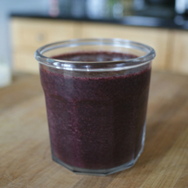
Ingredients

Total Ingredients: Per Blender:

- 9 c. of spinach
- 3 c. of cilantro
- 12 c. water
- 18 bananas
- 6 limes
- 1 ½ c. spinach
- ½ c. cilantro
- 2 c. water
- 3 bananas
- 1 lime
- 6 inches of ginger
- 1 inch of ginger

Procedure

- First, cut the kale and remove all sharp stems.
- Measure out just enough ingredients for one blender (ingredients listed on the right-hand side, above).
- Add all ingredients to a blender.
- Blend until smooth.
- Repeat until total ingredients (listed on the left-hand side) are gone.
- Serve.

