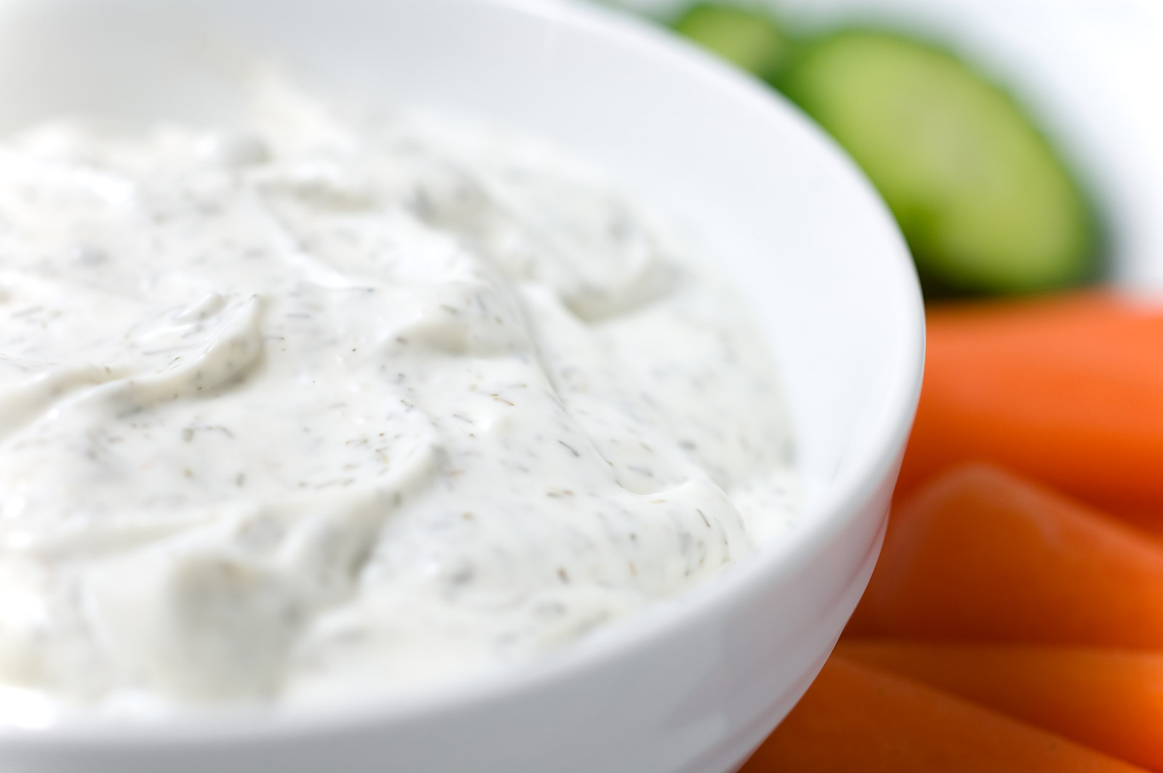
Ingredients

- 8 cups plain Greek yogurt
- 1 ¼ teaspoons dried dill weed
- 1 ¼ teaspoons garlic powder
- 1 ¼ teaspoons onion powder
- ½ teaspoon salt
- 1 ¼ teaspoon black pepper
- 3 ¾ teaspoons dried parsley

Procedure

- In a large bowl combine the Greek yogurt and spices
- Cut carrots
- Serve together

