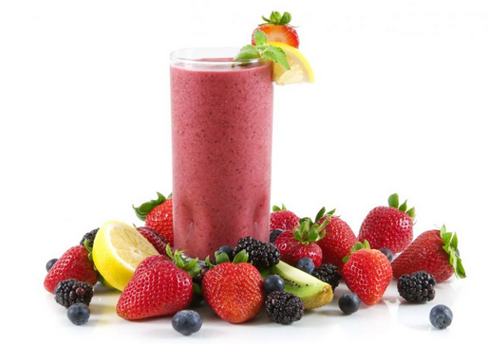
Ingredients

- 12 cups of water
- Pineapple
- Bananas
- Peaches
- Watermelon

Per Blender:
- 1 cup of water
- 1 cup of pineapple
- I cup of peaches
- 2 bananas
- 1 cup watermelon

Procedure

- Add 1 cup of peaches to blender
- Add 1 cups of water
- Blend until smooth
- Add 1 cup of pineapple
- Add 1 cup of watermelon
- Add 2 bananas
- Blend until smooth
- Sweeten with honey or apple juice if necessary

