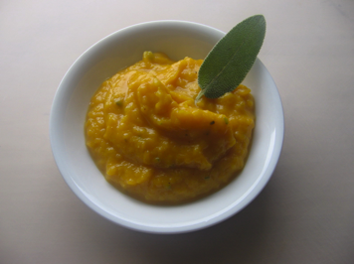
Ingredients
- Butternut squash
- 4 cans chickpeas
- Apple cider vinegar
- Apple juice
- 2 onions
- Salt and pepper to taste
- Small pumpkin (optional)

Procedure

- Cut up the onions and butternut squash
- Saute in a sauce pan over medium heat for 20 minutes
- Add 1cup apple juice to ½ cup apple cider vinegar until the onions and butternut squash are halfway covered.
- Add chickpeas
- Heat for another 10 minutes
- Add salt and pepper
- Use the immersion blender to blend until desired consistency is reached.
- Serve in pumpkin (optional)

