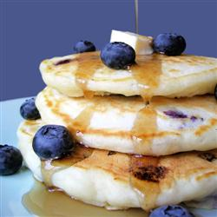
Ingredients

- Blueberries
- 12 C flour
- ¾ C sugar
- 8 tbsp baking powder

- 2 tsp cinnamon
- 1 tbsp salt
- 12 C milk
- 1 ½ C canola oil
- 12 eggs

Procedure

- Rinse all the blueberries
- Combine correct amounts of flour, baking powder, sugar, salt and cinnamon in a bowl and mix
- Combine milk, eggs and oil in a separate bowl
- Mix the milk, eggs and oil into the bowl of dry ingredients.
- Slowly mix in the blueberries
- Put a large greased pan over medium heat
- Put spoonfuls of pancake mix into pan. Turn when bubbles begin to form on top. Cook until golden brown.

