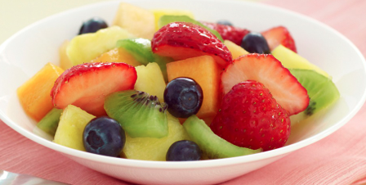
Ingredients

- 4 pints blueberries
- 2 pineapples
- 9 mangoes
- 2 cantaloupes
- 9 kiwi
- 4 limes
- 4 lemons
- 4 oranges
- 5 tbsp honey (more if needed)

Procedure

- First, wash the blueberries and check to make sure there are no small stems. If there are, detach and throw away.
- ADULT ASSISTANCE REQUIRED. Next, cut the pineapples carefully, by first cutting off the top and then (with the flat end down) cutting off the sides. Carefully rotate the fruit so each time you cut it is on a flat surface.
- Cut the mangoes. First, cut each mango into 4 ‘cheeks’ so you only have the pit remaining in the middle. Then tic tac toe each cheek, but do not cut through the skin. Turn the mango cheek inside out and scrape off the chunks with a spoon.
- Slice the kiwi
- Cut the cantaloupe. Don’t forget to scoop out the seeds from the middle after you do the on top chop!
- Combine the honey, lemon juice, lime juice, orange juice and orange zest and sprinkle on the salad.

